__________________________________________________________________
To: Dr. Dale Lumley
From: Kaden DeFazio KD
Subject: Research Proposal For Different Career paths in Information Technology
Date: April 14th, 2026
__________________________________________________________________

Introduction:
The purpose of this research is to find the different career paths available in Information Technology. As an IT major, I am interested in finding out about the different types of roles I can look forward to after completing my degree, along with the required skills, certifications, and hands on experience needed for these different positions. IT is a broad career field, so looking into jobs like cybersecurity, tech support, or networking, can help narrow down what exactly is the best fit for me.

This research will focus on entry level IT jobs, any career advancement opportunities, and the average salaries for the different jobs I find. According to the U.S. Bureau of Labor Statistics, computer and IT jobs are expected to grow within the next 10 years. This paper will help me better understand what my options are and make informed decisions about my future in IT.

Statement of The Problem:
The main question of this research is: “What career path in IT is best for me after I graduate?” IT offers a lot of opportunities, and it is very overwhelming to decide what direction to take because of the inane amount of roles there are under IT and each of their required skill sets. Some positions like tech support are going to be more client-facing problems while other jobs are going to need more technical knowledge in things like networking or cybersecurity.

This research is going to look at different IT career paths that I could take including a help desk technician, network admin, cybersecurity analyst, and more. I’ll take a look at the education that’s needed, certifications, and what the base pay looks like for those roles. I’ll also take a look at what roles are in high demand right now and offer the best advancement in the future.

Proposed Tasks/Methods:
To help me with my research project I’ll do the following:
- Use La Roche University’s library database and look into academic journals
- Analyze Information from the U.S. Bureau of Labor Statistics
- Research IT certifications and job requirements
- Look at Linkedin and Indeed for job postings and what they offer/require
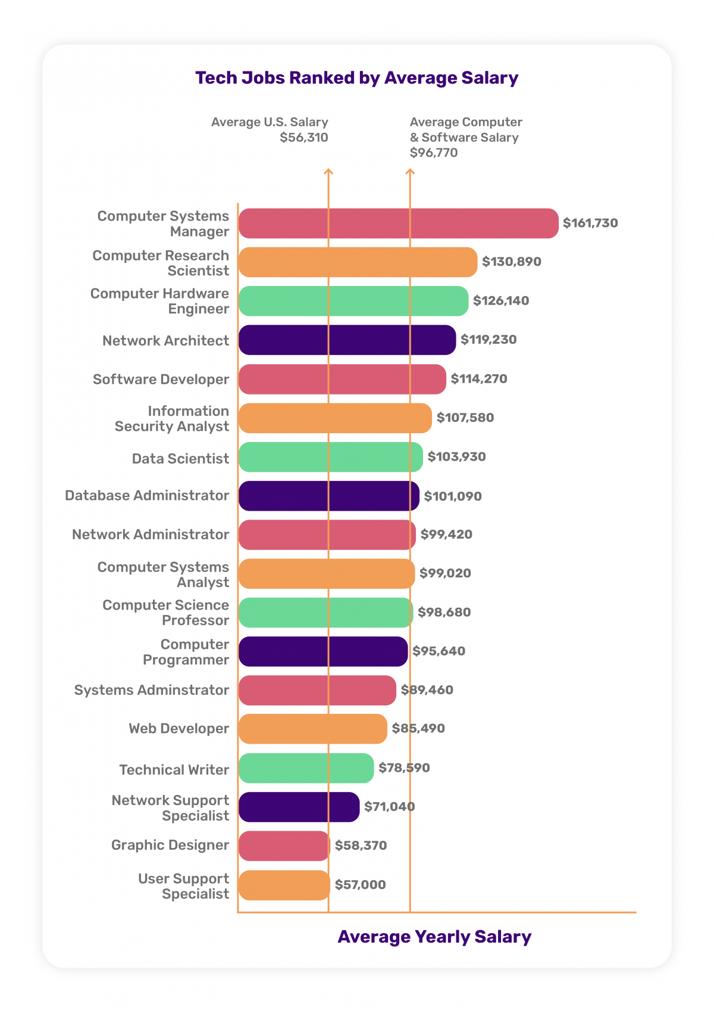
Data/Budget/Financial Considerations:
The information collected will also include salary ranges, certification costs, and any additional education expenses I would need to make post graduation. Some certifications like a CompTIA A+ require exam fees.

Potential Graphic:
I’ll also be including a bar graph that compares the average salaries of different IT careers like a tech support position all the way to a computer systems manager. Having this visual will make the information easier to understand and compare what job is the best fit for me.

Conclusion:
To conclude, this research is going to explore the vast amount of roles and career opportunities available in the IT field and help me choose the best path based on my interests and goals. I’ll do this by analyzing any job requirements, salaries, and potential advancement, so I can gain a better understanding of what I need to do after graduation.

